**Project on**

**House rental Management system**

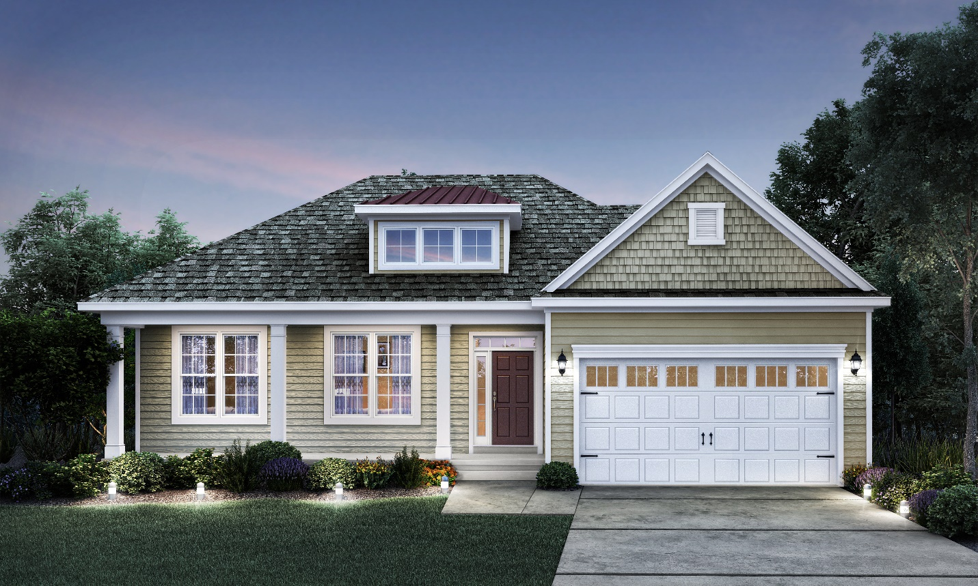

Sahara Magar

00175857

Computing Project

Level 5 in Computing

Softwarica College of IT and E-Commerce

Submitted to: Sudeep lal Bajimaya

Acknowledgement:

Finally this project was completed with the help of, teachers, senior sister’s brothers and friends. I have also done many research in net to complete the task.

I would like to thank Mr. Sudeep bajimaya for helping in my project. I have also watch many YouTube video regarding the rental systems.

Abstract:

We are stuck with technology when what we really want is just stuff that works. Housing sector remains vigilant to face the challenges of change by employing a new strategy that facilitates easy management of rental houses. Hence there is need to develop a rental house management system that can simplify work for the rental managers so that all their work can be efficient and effective. So, I have done the project on house rental management system which can solves the current renting system of the house.

To get information about how rental houses are currently being managed, I have gathered some information through which I find that the work done was manually with a lot of paper work involved. Papers can easily get damaged or get lost leading to loss of data. It is also expensive to keep on buying files to store your data and consume a lot of space. Getting a certain file to check data from many files becomes a difficult task. Considering those facts, I decided to develop a rental house management system that can solve all the problems experienced with the current manual system. The system is user friendly as, once to click the site then you can see the house and registration form. After you register the system you are allowed to use the other functions of the sites like booking They can sent the mail to the admin for the reviewing the system. They can search the houses according to the budget and location.so, lastly this web application is reliable, secure, time and cost saving which can be used by everybody. Due to the growing use of the technology this site is easy to use which solves the problems of renting system.

Table of Contents

Chapter 1. Introduction 7

1.1 Introduction to the project 8

1.2 Background to the system: 8

1.3 Overview of the system: 8

1.4 Justification of the project: 9

1.5 Aims and objectives: 9

Chapter 2.Analysis 9

2.1 introduction 9

2.2 Analysis methodology 10

2.3 Feasibility study: 12

2.4 Software Requirement Specification (SRS) 13

2.5 Use Case Diagram 16

2.6System Architecture: 19

Chapter 3. Design 20

3.1 Structural modelling 20

3.1.1 Dataflow Diagram 20

3.1.2 Class Diagram 23

3.2 Behavioural Modelling 24

3.2.1 Activity diagram 24

3.2.2 Sequence Diagram 28

3.3.1 Data Dictionary 33

3.3.2 Er Diagram 36

3.4.1 Prototyping 37

Chapter 4. Implementation 51

Chapter 5. Testing 51

5.1 Black Box Testing 52

5.2Unit Testing 65

6: Other project Issue 65

6.1 Limitation 65

6.2 Future work 65

6.3 Risk management 65

6.4 Configuration management 67

6.5 Other project issues 68

6.6 User manual 68

7. Conclusion 74

8. References 74

9. Appendix 75

**Table of Figure:**

**Figure 1 Rich picture for house Rental Management system** 10

**Figure 2 use case diagram for house rental management system** 16

**Figure 3-tier Architecture model** 19

**Figure 4 User DFd** 22

**Figure 5 Admin DFd** 23

**Figure 6 class diagram for house rental management system** 24

**Figure 7Activity Diagram1** 26

**Figure 8 Activity Diagram2** 27

**Figure 9 Activity Diagram3** 27

**Figure 10 Activity Diagram4** 28

**Figure 11 Sequence Diagram 1** 30

**Figure 12 Sequence diagram2** 31

**Figure 13 Sequence diagram 3** 32

**Figure 14 Er Diagram for house rental management System** 36

**Figure 15 home page of house Rental management system** 38

**Figure 16 About Us page of house rental management system** 39

**Figure 17 Property page of house rental management system** 40

**Figure 18 blog page of house rental management system** 41

**Figure 19 help page of house rental management system** 42

**Figure 20 login page of house rental management system** 43

**Figure 21 login page of user Sahara** 44

**Figure 22 register page of house rental management system** 45

**Figure 23 login page of Admin** 46

**Figure 24 Admin dashboard** 47

**Figure 25 user who have login** 48

**Figure 26 list of the houses** 48

**Figure 27 form for adding houses** 49

**Figure 28 Users who have booked the houses** 49

**Figure 29 list of blog used** 50

**Figure 30 form for posting blog** 50

**Figure 31 Login Form for testing** 52

**Figure 32 Registration Form for Testing** 53

**Figure 33 Add House Form used for testing** 54

**Figure 34 View house form used for testing** 55

**35 Edit house form used in testing** 56

**Figure 36 Form before deleting the house** 57

**Figure 37 Form After Delete of one House** 58

**Figure 38 Booking Form used in testing** 59

**Figure 39 Add Blog form used during testing** 61

**Figure 40 Edit Bog form used during testing** 62

**Figure 41 Delete Blog Form** 63

**Figure 42Tree structure for HRMS** 67

**Figure 43 home page of HRMS** 68

**Figure 44 Registration page for users** 69

**Figure 45 login page for user** 70

**Figure 46 blog page** 71

**Figure 47 property page** 72

# Chapter 1. Introduction

Rental house management system is the system for management of the renting system of the house. House is the basic need to the people for living. So, to make the easy life style and easily accessible for all the people house rental system is introduce which can provide all the needed facilities. We also make it mobile friendly as, users can search for the reliable and vacant house and can transport any time. Tenants can search randomly according to their wish based on unique area and city. They can also search the houses according to their budget. Different types and design of houses are kept in the sites. Users can also select the house/flat by seeing the picture of houses. One users can only book the one same house. If any vulnerability occur in the users then admin can cancel/deny the users from booking.

## 1.1 Introduction to the project

This whole project is about houses rental management system. In this project a website is made through which the user can easily search their desirable house at their desire price. Users can also search the house at different location and also the users can get help in using the site by clicking the help link. They can book the house from anywhere if they like the houses. There is also provided an option in which they can chose flat or house for booking. They can also sent the mail to the admin for reviewing the sites.

## 1.2 Background to the system:

House rental management system is the web portal in which the users search for the house in rent with all their needed facilities. Users can book the hose/flat in rent from any place which saves the time and cost. Also can review the system by sending the mail to the admin if they feel any uncomfortable in using the site. You can also see the house according to your budget range. You can also chose the location where you want the house.

One should provide the valid email and password to get login to the system. If the users are not valid or details are incorrect then admin has right to deny their booking.

## 1.3 Overview of the system:

The system includes the whole rental management. It also provided the different services according to the requirement of the customers. Helps to find the different and their desire house in their desire location with major facilities in reliable price. Also provides the facility of searching the houses/flat by using certain tags.

Users can also online booked or reserved the house which can save their time and cost. . They can also easily search the location of the house which they are willing to buy and can also see the review by sending the mail. Users are allowed to view and edit their profile and booking details.one users can book only one same property. Functionally of my system is given bellow;

* Welcome form (Admin/users login form).
* Users registration form
* Online booking
* Google map/location.
* Dynamic rental search.
* Dynamic mail system.
* Contact us form.

## 1.4 Justification of the project:

The whole project is about house rental management system. For the easiness of the people this system is designed or made. This system saves the time and cost of the people. They can easily find the desire house/flat by searching the houses online. They can also make online booking for the houses. They can also search the house at different location at their budget. They can also allow to send the mail to the admin if they want to review to the system or for booking the house. So, the overall project is done by following the different types of methodologies of work. Different types of structure were used to analyze the system.

## 1.5 Aims and objectives:

**Aims:**

1. The aim of the project is to book the house or search the efficient house from browsing the website by sitting anywhere at any time.
2. Is to provide the proper and updated information about the house rent.
3. Aims to find the reliable, comfortable home in fix time and cost.

**Objectives:**

1. To develop a system that allows the users to view the customer’s data as well as house records.
2. Develop a system that allows the users to add, edit, search, and delete the data from the database.
3. To manage all the house rent, client.
4. To analyses the requirement specification of the client.
5. To produce the system which helps the client for easy payment through online booking.
6. To ensure the security that unauthorized people cannot get access to the personal data.

# Chapter 2.Analysis

## 2.1 introduction

A methodical assessment and assessment of information or data, by breaking it into its segment parts to reveal their interrelationships. Analysis is the most important parts in the business as it helps in dividing the macro problem in micro parts. Analysis is also the most important parts in development as it helps to minimize or divide the work in different small parts.

## 2.2 Analysis methodology

Soft system methodology is used in the analysis as soft system methodology is based on people focus. As, Rental house is the need for the people and focused on people requirements.

**Rich Picture** (PHAM, 2019)

Rich picture is used to evaluate the whole situation (project) in a board and open way. It requires all the physical entities. It also helps to evaluate or describe the current issues or problem of the system. It is develop from the soft System methodology.

The current system of renting the house is more time and cost consuming as, client had to visit the each house and had to made contact with different brokers. Rich picture figure is shown below which describing the current system of renting the house.

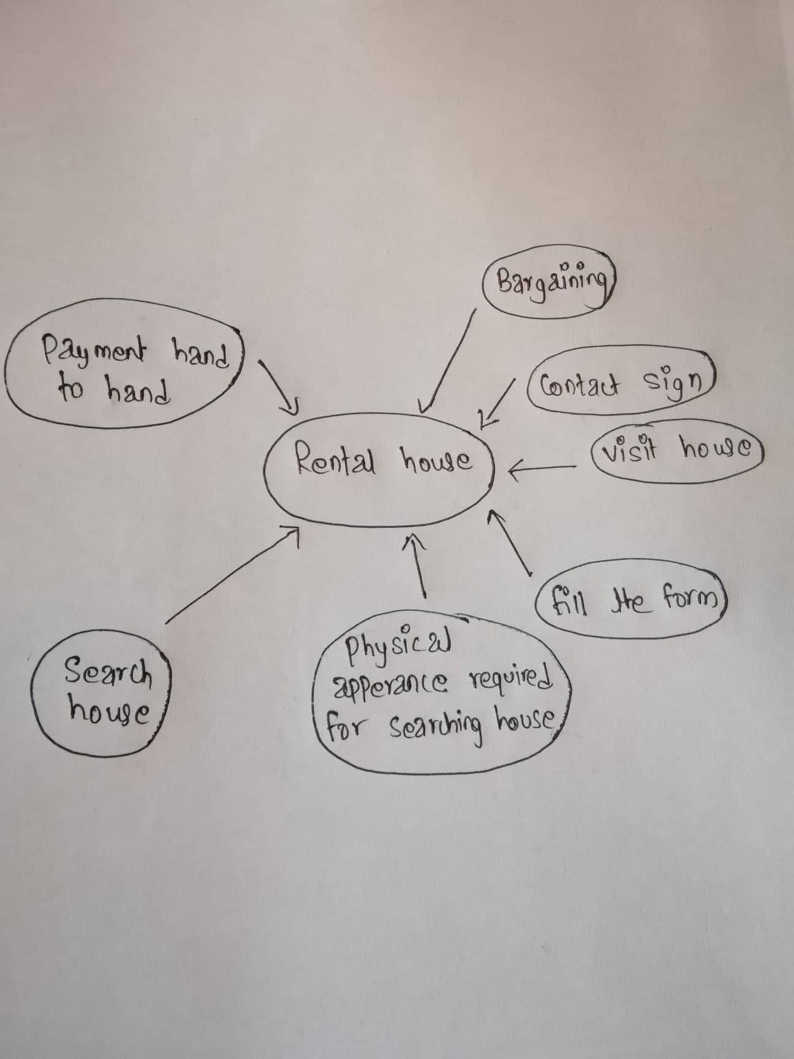

**Figure 1 Rich picture for house Rental Management system**

**CATWOE**

It is also the part of the SSM which can be used to encourage thinking about the problem and provide the appropriate solutions. It is also a problem solving method in which can be used to look at issues from six unique perspectives.

1. **Customer:** Customer or client is the users of the system and gets direct/indirect impact from the system. Also get effect or benefits if certain changes is made in the system. It is the 1st step in which the users first directly interact with the system by filling the registration form with their detail which is the customer for the system.
2. **Actor:** Those who are involved in the current situation (system). Actor may be in different form. For the current system Actor is Admin. Actor directly involved in solving the problem and making the new decision.
3. **Transformation:** It means what may be the effect of developing the system in current process. It considers the input and output from the system. The customer or users or clients should be able to use the system more easily and reliably. The current system is not reliable as it is manual, time and cost consuming. People have to be physically appear for searching the house and have to fill the paper form. This system is replaced by the system/application in which the customer and stakeholder can made the direct contact and conversation and customer can visit the property site and see the information online.
4. **World View**: It refers to the real world problem on system. It is also an overview of in and outside work which may influence in the development of the system. It include the prospective and view of the different persons on particular problem. Current system problem can be viewed in different way with different solution the owner and tenant have the different view on the same system as owner view from the business need and tenants may have view point to get the reliable facility in reliable cost. Also the users may have viewpoint that their property are rented properly and safely.
5. **Owner:** One who owns the system? For the current system/application admin user of the application is the owner who has the authority to make changes in the project. Decision making and future situation handling is also done by the owner (Admin).
6. Environment: In this step, there may be the different constrain and need to be aware of the demand of legal ,political, economic , social, technical which can disturbed the growing success of the system. These can be solved differently with different problem solving method.

## 2.3 Feasibility study:

Feasibility is one of the most important steps in software development. Feasibility study is the initial plane phase of any design which unites the component of the knowledge that indicate if the project is possible or not. Analysis and evaluation of the project is done to know if the project is technically, legally, socially feasible with in estimated cost, Solutions can be easily find if we know the project is not feasible in early stage of development.(Anon., 2019)

Five types of feasibility which can be done in our project are describe bellow;

1. **Technical Feasibility:** Helps the organization to find the technical resources are useful for the project or not. Different types of software and hardware, technical team are determined and evaluated. My system/application is technical feasible as it can be run me mobile and computers.
2. **Economic Feasibility:** Means the financial transaction need or used in developing the system. Helps in managing and calculating the cost required in the system which helps to find whether costing for developing the system is high or not. If the cost is high then solution can be made by balancing the amount in time. As, the system helps to reduce the cost because they don’t have to visit the every place in search of house.
3. **Legal Feasibility:** This system fulfill all the legal requirement. Cannot get the copyright.
4. **Social Feasibility:** Can be consider as an important factor. If the developing system negatively impact the social environment then it will be not feasible to develop. My system is socially feasible as all types of people can use it there is no restriction for cast, culture, religion, color etc.
5. **Political Feasibility:** The developing system can make impact re effect in political parties. Developing system will not impact because all the parties can use it.

**Fact Finding Methodology:**

There are different types of technique and concept used for gathering the information. Information gathering is done at early stage of developing the system i.e. in analysis. Some of the information gathering method used in developing the system are;

1. **Questionnaires:**

It is the method in which the information are gathered by raising the question to the group of the people. Different or same question can be asked to the different person. Yes /no/multiple choice question should be asked in order to make them easy to answer. Some of the questions are;

Does the rental amount fit your budget?

Is the living area appropriate?

1. **Interview:**

It means the face to face communication with the interviewer. It is also one of the easy way of gathering information as personal view can be considerate at the same time by observing the interviewer facial expression.

## 2.4 Software Requirement Specification (SRS)

**Functional Requirement**

|  |  |  |  |  |  |
| --- | --- | --- | --- | --- | --- |
| **Id** | **Title** | **Description** | **Purpose** | **Dependencies** | **Impact** |
| **F1** | **Registration** | Self-description of the user is provided by themselves and new user is register. | To view the information and feature of the system used by the user. | **F2** | **Must have** |
| **F2** | **Login** | Login is done by only register users with verification | To securely access the system | **F1** | **Must have** |
| **F3** | **Search Property** | Customer/client can search their desirable (property) and can view the available property. | To find the desire property and to get the information of the property that already exist. | **F2,F4** | **Must have** |
| **F4** | **Add property** | Detail about the property are added for advertisement. | To know the detail or new information about the property advertisement. | **F2** | **Must have** |
| **F5** | **Edit property** | Certain changes can be made and maintained by the certain authorized person. | To add or update the old detail about the property which can be made by the user. | **F1, F2, F3** | **Must have** |
| **F6** | **Book property** | Clients can book the property if they find the suitable property. | Property shown in the advertisement can be booked. | **F2,F4, F3** | **Must have** |
| **F7** | **Delete property** | After the property is rented advertisement is deleted. | To deleted the advertisement of the rented property. | **F2,F3, F4, F5** | **Must have** |
| **F8** | **Send email** | Owner of the property are allowed to receive the email from each client. | In order to book the property by sending email. | **F2, F6** | **Should have** |
| **F9** | **Check advertisement** | Advertisement are managed by admin. | To keep only valid property advertisement or information of property. | **F2, F4** | **Should have** |
| **F10** | **Remove User** | User can be removed by the admin if they cat misbehaviourly/fake. | To maintain and manage the user. | **F2** | **Could have** |
| **F11** | **Post Blog** | Only the admin can post blog with specific tags. | Makes easier for users to search the details of the house by typing the specific given tags. | **F2** | **Should have** |

**Nonfunctional Requirement**

|  |  |  |  |  |
| --- | --- | --- | --- | --- |
| **Id** | **Title** | **Description** | **Proposes** | **Impact** |
| **NF1** | **Reliability** | System should not be failed during use. Should be run without any interruption. | Can be easily assess by any users. | **Must have** |
| **NF2** | **Performance** | Should be run fast and show the all detail in certain time. | Add ,edit and property function should be hide with in a sec. | **Should have** |
| **NF3** | **Availability** | Website should be available and can be used at any time. | Can be used by user from anywhere at any time. | **Must have** |
| **NF4** | **Usability** | User friendly interface is created. | User friendly and easy to access to the users. | **Must have** |
| **NF5** | **Scability** | Ability of a system to manage and grow the amount of work | To measure the growth of the user | **Should have** |
| **NF6** | **Capacity** | System/application can handle or store the data | To measure the collected data. | **Could have** |
| **NF7** | **Recovery** | Should be easily and fast recovery from any virus and error. | To prevent the previous data lose. | **Should have** |
| **NF8** | **Security** | Valid password and email of users is required to login | To prevent data loss and to maintain security of data. | **Must have** |
| **NF8** | **Error handling** | Appropriate message is provided to guide the users to solve the error | Essential of validation of users input. | **Could have** |

**Hard ware and software specification:**

**Hardware:**

Hard disk space: 256 mb

Ram memory: 4 GB

**Software:**

Operating system: windows 10, Windows 8

Database server: Xamp

Text Editor: Vs. code

## 2.5 Use Case Diagram

Use case can be explain as the graphic representation of the interaction of the users with the systems. Used in the analysis process as it helps to explain, identify the system requirement easily. Can be considers as a sets of actions which describe the whole systems. (Anon., 2019)

Given diagram bellow shows the use case of house Rental management system.

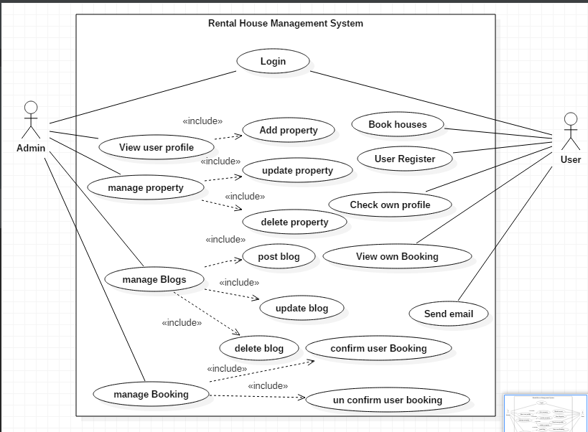

**Figure 2 use case diagram for house rental management system**

Above diagram represents the interactions of the admin and the users with the system. Admin are the persons who manage the whole systems and users are the website visitor who may be different in each time. Users have to login to the system in order to use the systems functions like booking. Website visitor/ users generally can view, search the property but cannot add and delete the property. Only the

Admin can delete, add and update the property. Admin can also post, update and delete the blog. Also has authority of confirm and UN confirm the users booking.

**Login**

Login functions helps to keep the system secure. Users and Admin have to login to the system by entering the correct email and password in order to use the system functions.

**Register**

Users need to provide the proper details in order to get register. Unique email should be provided.

**Add property**

It is process of adding the property to the system. By adding the different and more property users/ website visitor can select their desire property easily.

**Edit Property**

This process shows that any error in adding property can be corrected. Only the admin can edit the details of already added property.

**Delete property**

This process shows that already booked property can be deleted. Confusion in booking can be maintain by deleting the property which has been already booked.

**Booking**

Only the register users have the authority to book the property. One users can book only one property.

**Send Email**

Any website visitor/ users can send the email to the admin regarding the booking, complains, reviews etc.

**NLA**

Rental house management system is the system for management of the renting system of the house. House is the basic need to the people for living. So, to make the easy life style and easily accessible for all the people house rental system is introduce which can provide all the needed facilities. We also make it mobile friendly as, users can search for the reliable and vacant house and can transport any time. Tenants can search randomly according to their wish based on unique area and city.

**Identifications of noun and verbs:**

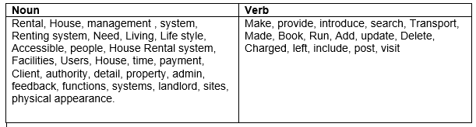

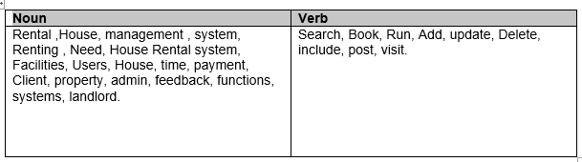

**Final classes are**

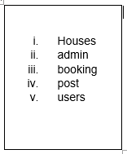

## 2.6System Architecture:

The system architecture that will be using for this project will be 3-tire. System Architecture is the conceptual model which only defines the structure, view and behavior of the system. The description of the whole system is done by this architecture. 3-tire is the flexible and faster the application. It is 3-tire structure is describe bellow.

1. **Presentation tire:**
2. **Application/Business tire:**
3. **Data tire:**

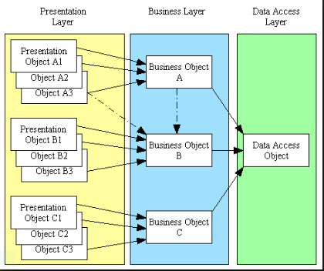

**Figure 3-tier Architecture model**

**Moscow prioritization**

Prioritization means giving the first importance to the required functional one. Moscow strategy is a priority technique used in the analysis, software development, and project management. It stands for must have, should have, could have and won’t have.

1. **Must have:** All the requirement should be fulfilled. If one function or requirement is miss or not completed then the project is failed. Without must have function the project can be consider as failure and cannot be deliver.
2. **Should have:** they are not as time critical and requirement can be replaced or fulfilled by other way.
3. **Could have:** Requirement are desirable and which may not be necessary. Can be used only for user’s experience and customer satisfaction. Without this requirement system can be easily run.
4. **Won’t have:** Functions which may be not required in present but can be planned and implemented in future for better system

# Chapter 3. Design

Design is the phase or stage after the analysis. It is also the plan or process in which the initial functions and structure of the software/system are describe. All the structural and logical planning of the software are developed in this phase. There are different phases in the design which are Structural modelling, Behavioural modelling, Database modelling and UI modelling. This phases are used to explain all the system functions which helps in system development.

## 3.1 Structural modelling

### 3.1.1 Dataflow Diagram

Dataflow diagram is way or method of representing the flow of data or the process in the system .It is also a graphical representation of the data flow in which the data are transfer from input to the file storage then generate a report. Provides information about the input and output of the system entities. (Donald S. Le Vie, 2019)

1. **Justification:**

DFd is used to show the flow of the data in my system. It is used to show the flow or process of how the information is used in the process. I have chosen the DFd among other structural modelling because; it describe the proper boundary of my system. Helps in communicating users with the current/ existing system. It is easy to recognize/understand.DFd can be easily understand by technical or nontechnical person. Shows the detail of systems component.

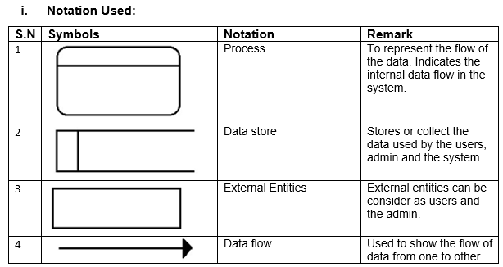

1. **Diagram:**

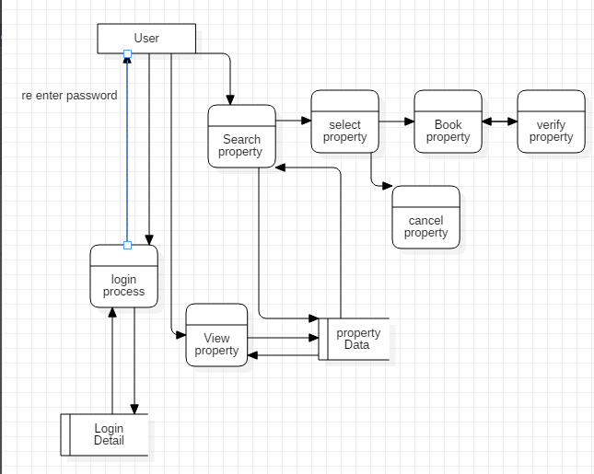

**Figure 4 User DFd**

As data flow diagram represents the flow of the data, process in the system. First diagram shows the users data flow diagram in which the users first login to the system by entering the username and then password. System validate the username and the password if the username and password is correct then system stores the data, if incorrect then ask for re validation. Login data are store in the database. Then users search and view for the property. The searching and viewing process is shown by the process diagram and their database is store in the data base which is represent by data store figure.

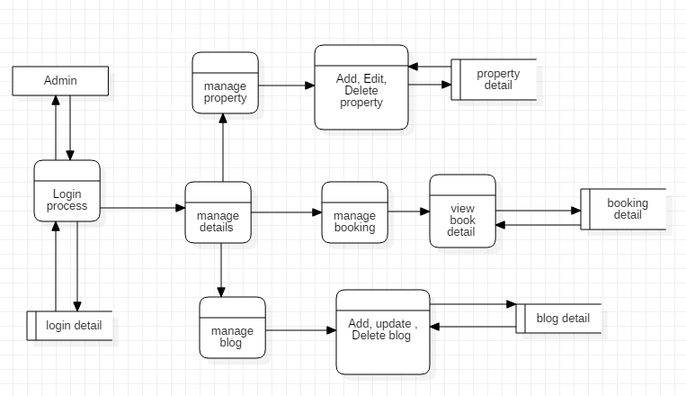

**Figure 5 Admin DFd**

Second figure shows the flow diagram in which the admin login the first login to the system and manage all the users’ details advertisement and property. In this figure admin has manage the property details, users and also manage the booking. Only the admin can add, update and delete the users and property.

### 3.1.2 Class Diagram

In software development class diagram is the structural representation of the system which shows the relation between the attributes, entity. A class diagram in the Unified Modeling Language (UML) is a sort of static structure diagram that describe the structure of a by showing classes, operations (or method), attributes and the connections among object of the system.

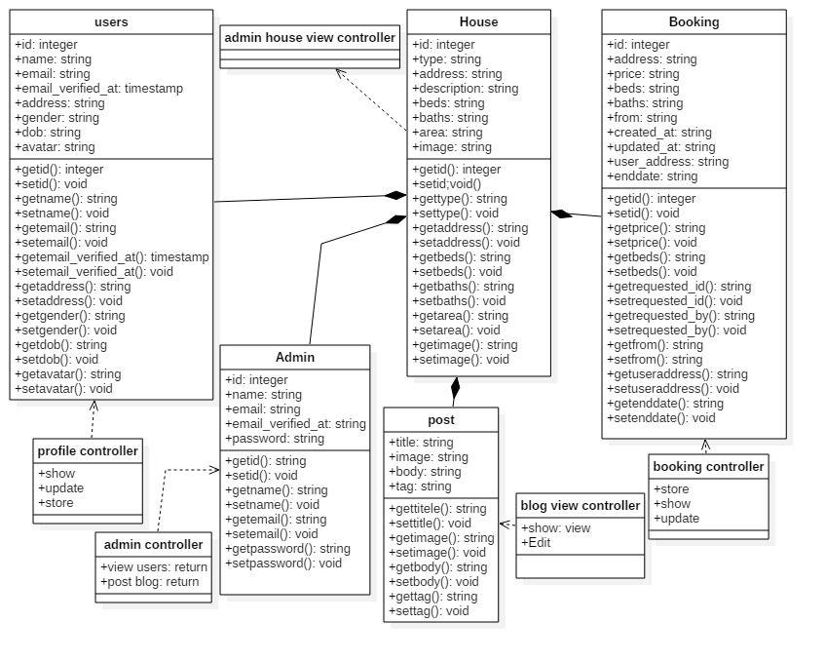

**Figure 6 class diagram for house rental management system**

## 3.2 Behavioural Modelling

### 3.2.1 Activity diagram

1. **Justification**

Activity Diagram is graphical and Behavioural modelling of the software which represent the work flow of the software. It is also the step wise activity or action which helps in describing the whole process of the system.

I have chosen the activity diagram for my system as, it helps to show real/actual work flow in the system. Helps in use case analyzing and describe the users and system action in clear way. Also describe the further action and their occurrence.

1. **Notation Used**

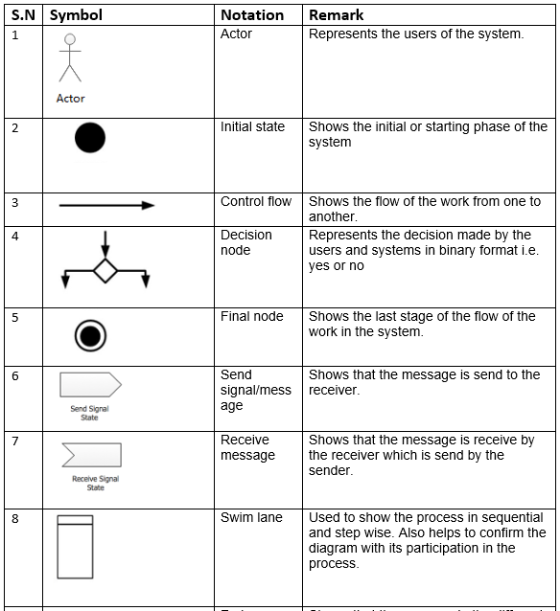

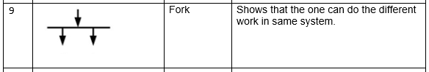

1. **Diagram**

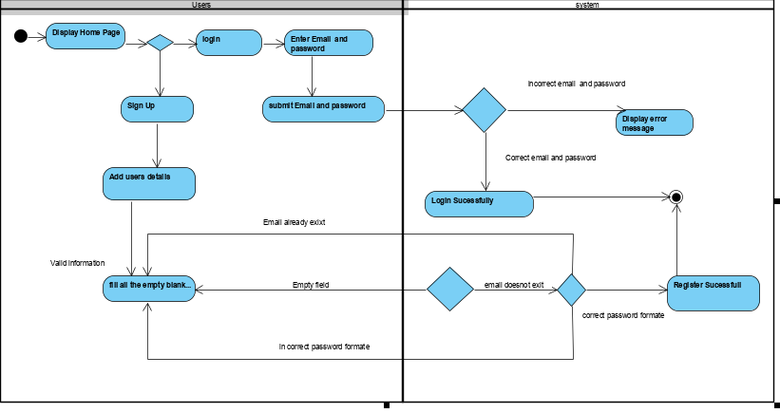

**Figure 7Activity Diagram1**

The above activity diagram shows the flow and activity perform by the users in the system this is the first activity perform by the users in the system. This activity shows that any/all users can use the system but they cannot booked the property. They have to login to the system to use the further system functions. The users have to register and have to enter their valid information. Users have to enter their valid username and password to login to the system. Users cannot control the property detail. They can only add their property details and update the property.

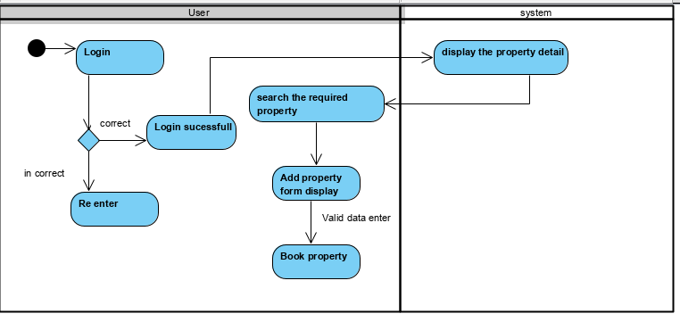

**Figure 8 Activity Diagram2**

The above activity diagram shows the activity between user and the system. Only the register users can use the functions of the system after login. Users can only book the property after login.

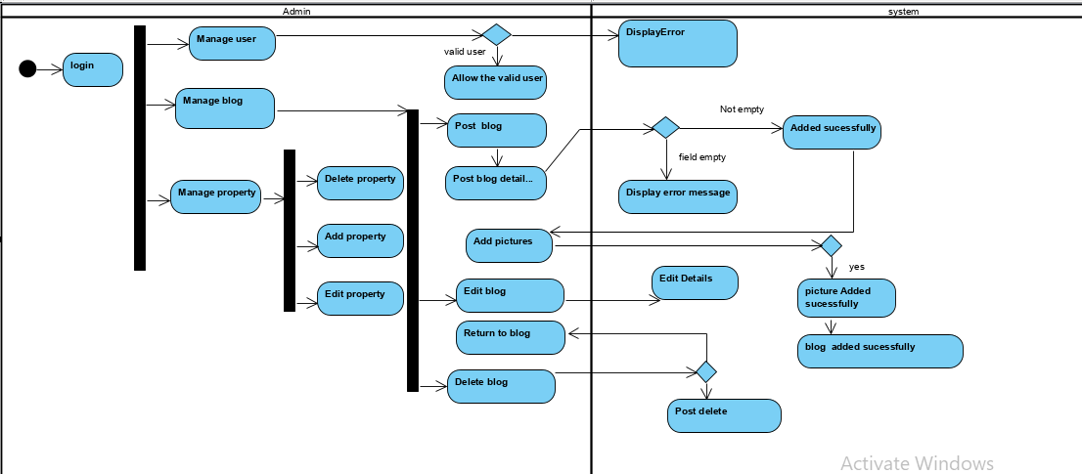

**Figure 9 Activity Diagram3**

Admin also should login to use the system. Admin can manage the users and blog. Admin has control of all the property in which admin can add, update and delete the property. Admin also manage the user booking in which the user can only book the property after admin confirmation.

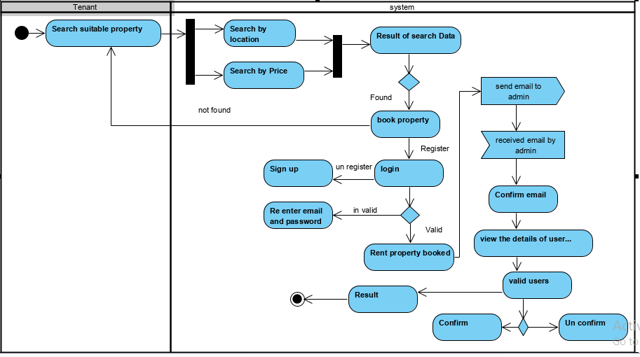

**Figure 10 Activity Diagram4**

Above diagram represent the work flow of the tenant. Tenant can also be consider as the guest users in which they have to sign up first in order to get login to the system. The system validates all the information provided by the users. User Email and password should be unique. The guest users or tenant booked the property after login and confirm the email by the system.

### 3.2.2 Sequence Diagram

1. **Justification**

Sequence diagram is the diagrammatic representation of the system. It shows the object interaction and display as message. Sequence Diagrams are communication diagram that detail how activities are completed. They are time center and they shows the request for the interaction outwardly/visually by utilizing the vertical hub of the diagram to speak to time what messages are sent and when.

The following points represents why the sequence diagram is important to the system.

* + It helps to show the work flow of the system in diagrammatic way.
  + Architectural and logical problem are easily identified.
  + It helps to represent the dynamic view of the system which makes easier to view the system process.

1. **Notation used**

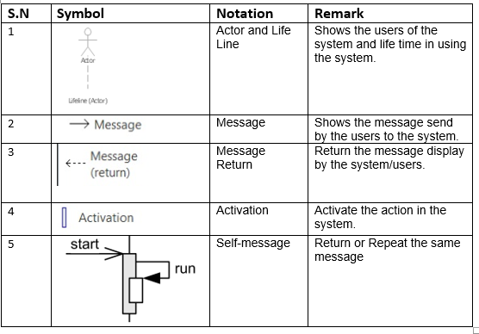

1. **Diagram**

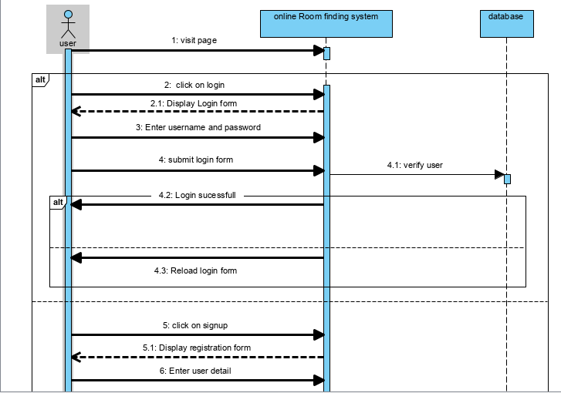

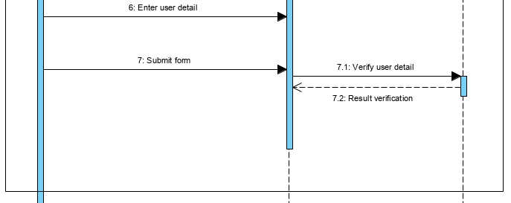

**Figure 11 Sequence Diagram 1**

First figure shows the works flow of the system in which the user login to the system and system verify the username and password which was save in database. If the users is unregister then the user can sign up the form and the register data is store in database.

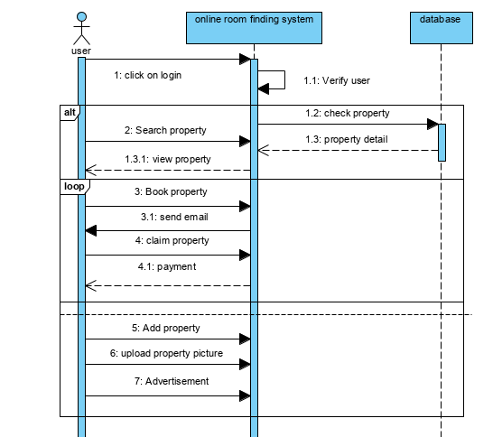

**Figure 12 Sequence diagram2**

This diagram shows that users should login to the system in order to booked property. First the system verify the users as, user data is already record in database. After login user can search, view and booked the property. Property details are already saved in the database. If the property is booked by the users then email is send to the users and email is confirm then property is claim or booked.

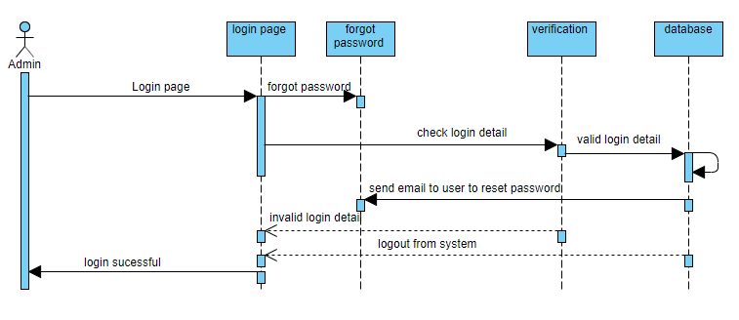

**Figure 13 Sequence diagram 3**

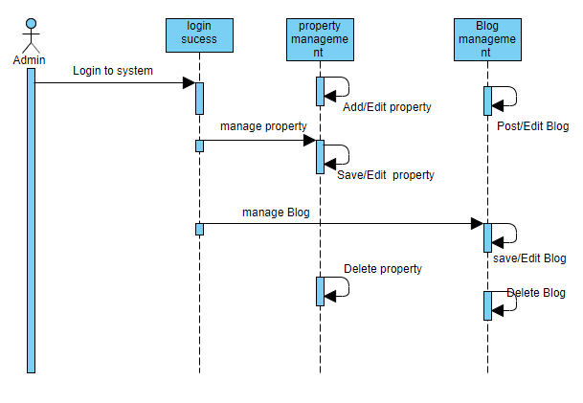

**Figure 10 Sequence diagram 4**

## 3.3.1 Data Dictionary

1. **Justification**

Data dictionary is define as the collection of the data, entity, attributes, name which are been used in database including their property.

Keeps the record of the document which contain database and metadata.

Keeps the record about the objects such as data relationship, data ownership etc.

Metadata of the Er diagram are created bellow in the table.

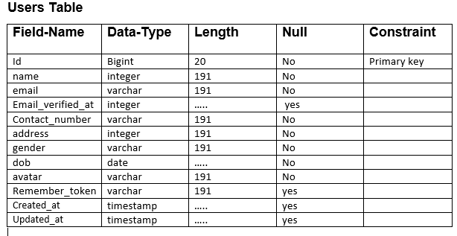

**Admin Table**

|  |  |  |  |  |
| --- | --- | --- | --- | --- |
| **Field-Name** | **Data-Type** | **Length** | **Null** | **Constraint** |
| Id | Bigint | 20 | No | Primary key |
| Name | varchar | 191 | No |  |
| Email | varchar | 191 | No |  |
| Email_verified_at | timestamp | ….. | No |  |
| password | varchar | 191 | No |  |
| Remember_token | varchar | 191 | No |  |
| Created_at | timestamp | ….. | yes |  |
| Updated_at | timestamp | ….. | yes | Foreign key |

**Booking Table**

|  |  |  |  |  |
| --- | --- | --- | --- | --- |
| **Field-Name** | **Data-Type** | **Length** | **Null** | **Constraint** |
| Id | Bigint | 20 | No | Primary key |
| property | varchar | 191 | No |  |
| address | varchar | 191 | No |  |
| Customer_address | varchar | 191 | No |  |
| Price | varchar | 191 | No |  |
| Beds | varchar | 191 | No |  |
| Baths | varchar | 191 | No |  |
| Area | varchar | 191 | No |  |
| Requested_id | integer | 11 | No |  |
| Requested_by | varchar | 191 | No |  |
| From | varchar | 191 | No |  |
| To | varchar | 191 | No |  |
| Img | varchar | 191 | No |  |
| Status | varchar | 191 | No |  |
| Created_at | timestamp | …….. | yes |  |
| Updated_at | timestamp | ……… | yes |  |
| User_id | Bigint | 20 | No | Foreign key |

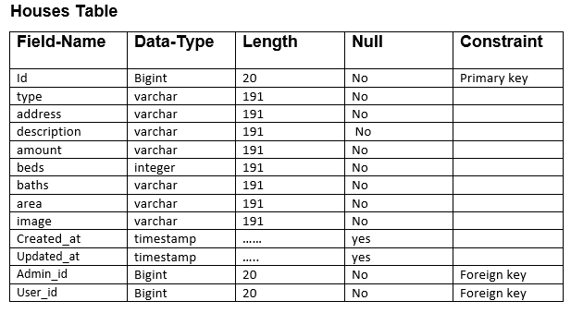

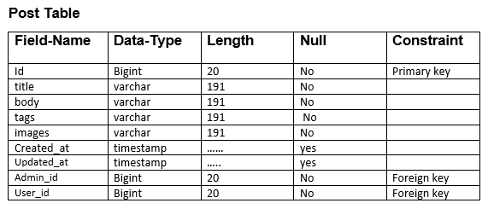

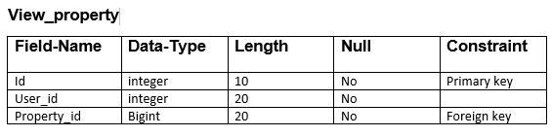

**Password_Reset**

|  |  |  |  |  |
| --- | --- | --- | --- | --- |
| **Field-Name** | **Data-Type** | **Length** | **Null** | **Constraint** |
| Email | varchar | 191 | No | Primary key |
| Created_at | timestamp | …… | No |  |
| Admin_id | Bigint | 20 | No | Foreign key |

### 3.3.2 Er Diagram

Er diagram is the entity relationship diagram which shows the relationship between entities like object, conceptual related to each other and people with the system. Er diagram can also be defined as the conceptual diagram. ER diagram are related and identified with Data structure Design (DSDs), which spotlight /focus on the connections of components inside elements rather than connections between substances/entities themselves.

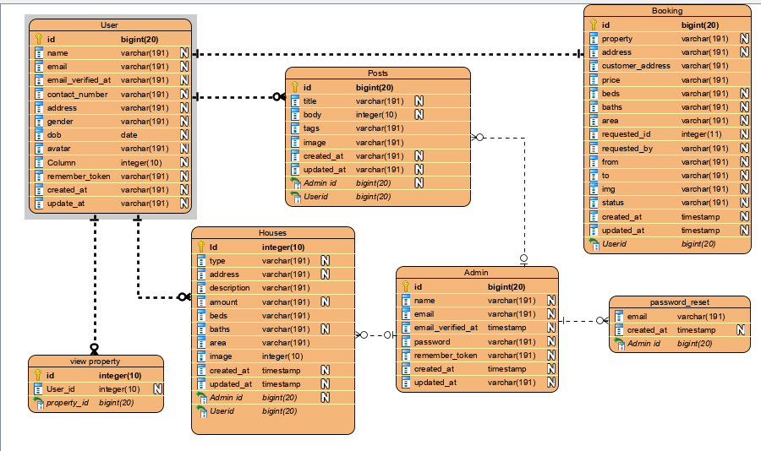

**Figure 14 Er Diagram for house rental management System**

### 3.4.1 Prototyping

Prototyping means the initial phase or stage from which the whole software is developed. A first full-scale and generally practical type of another kind or plan of a development. Also helps to minimize the occurrence of the error and it is easy to update.

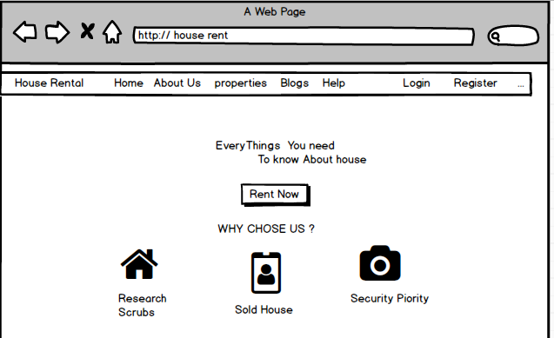

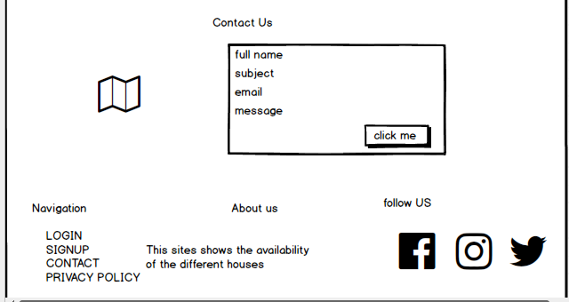

**Figure 15 home page of house Rental management system**

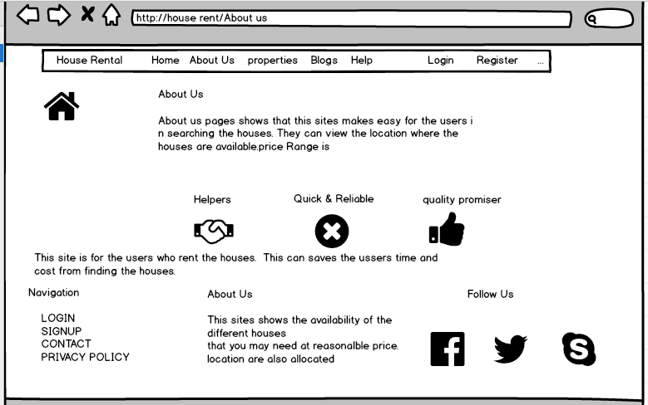

**Figure 16 About Us page of house rental management system**

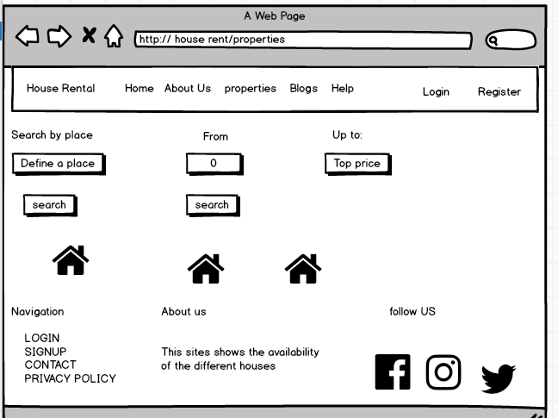

**Figure 17 Property page of house rental management system**

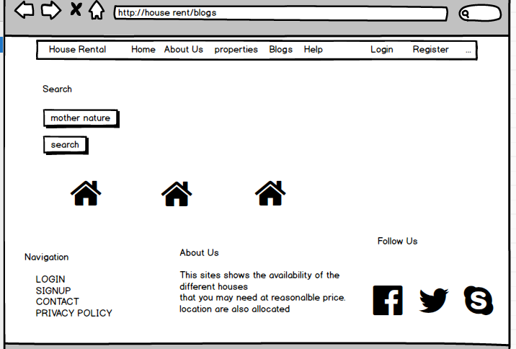

**Figure 18 blog page of house rental management system**

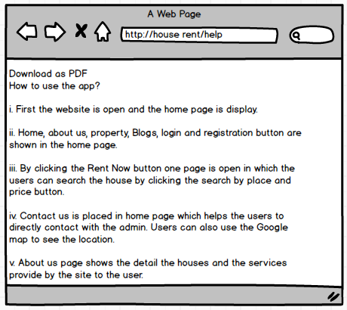

**Figure 19 help page of house rental management system**

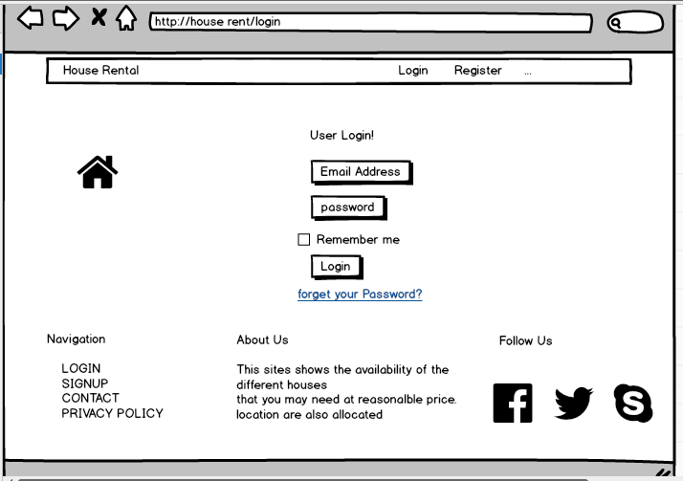

**Figure 20 login page of house rental management system**

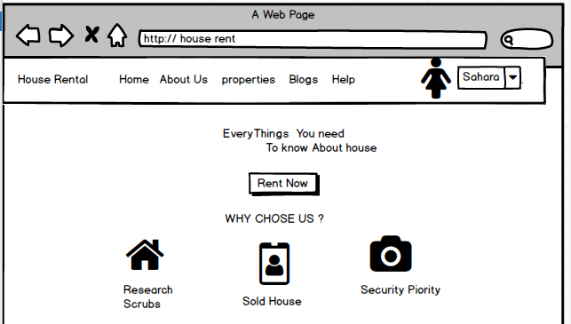

**Figure 21 login page of user Sahara**

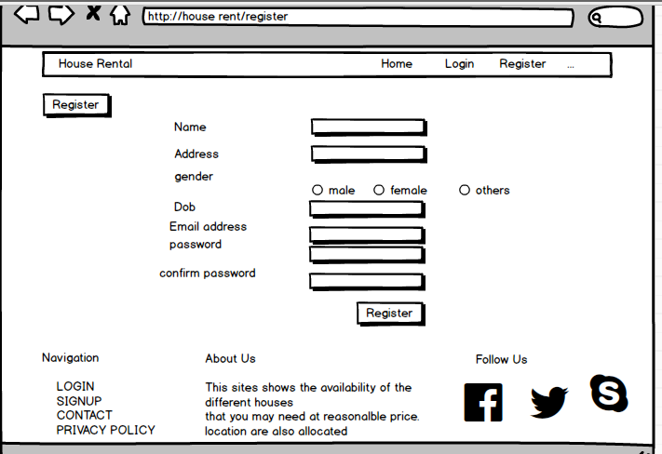

**Figure 22 register page of house rental management system**

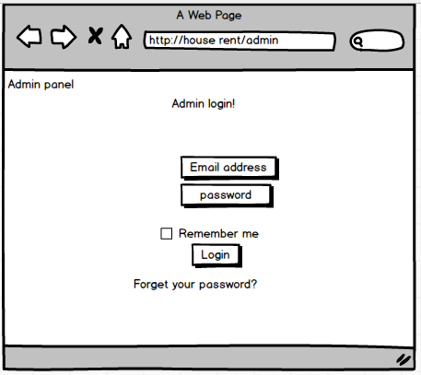

**Figure 23 login page of Admin**

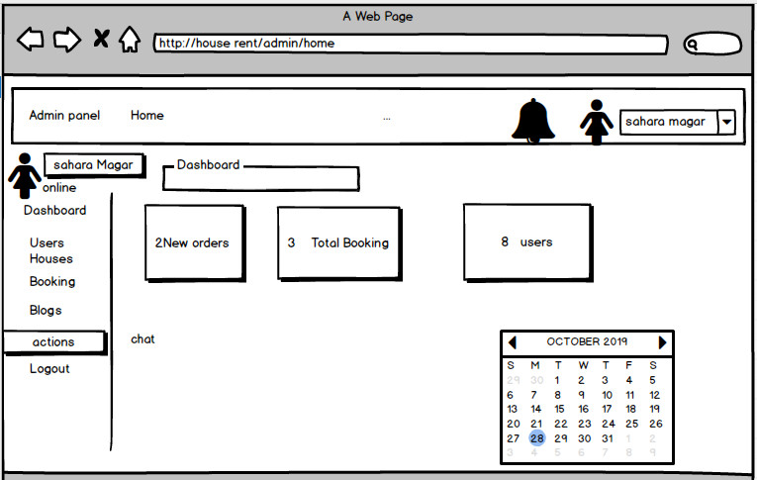

**Figure 24 Admin dashboard**

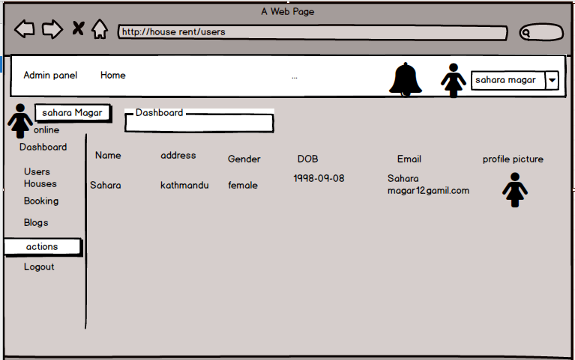

**Figure 25 user who have login**

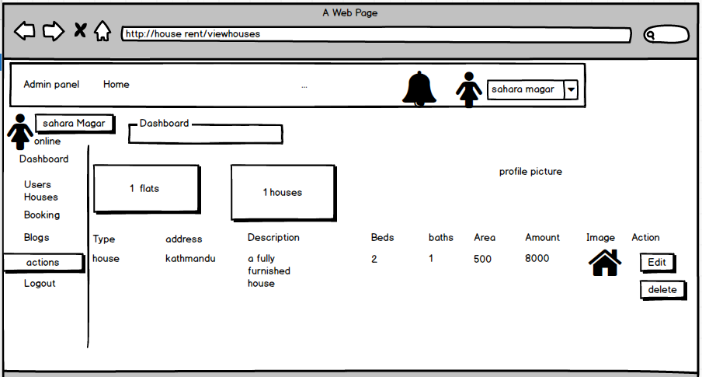

**Figure 26 list of the houses**

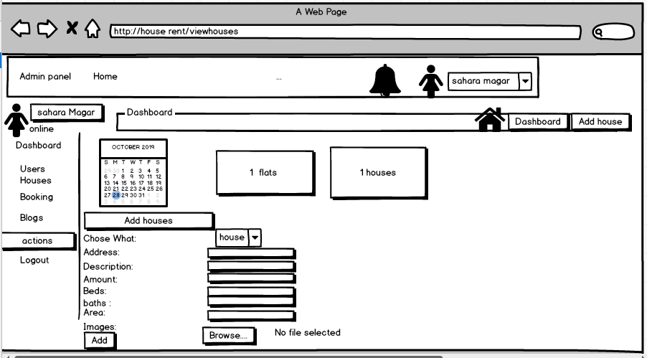

**Figure 27 form for adding houses**

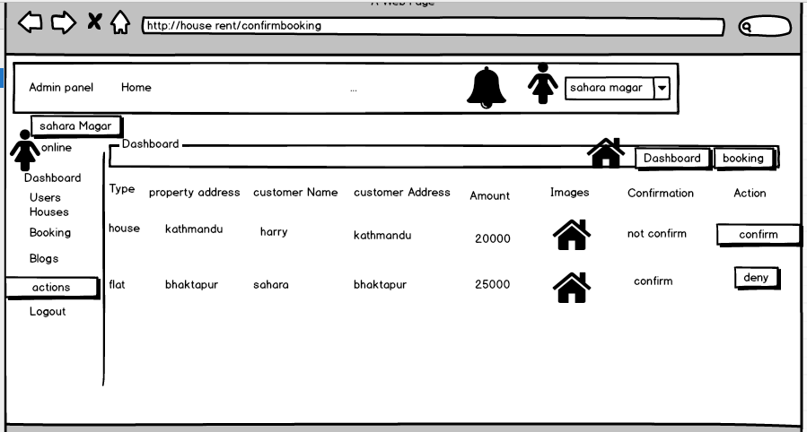

**Figure 28 Users who have booked the houses**

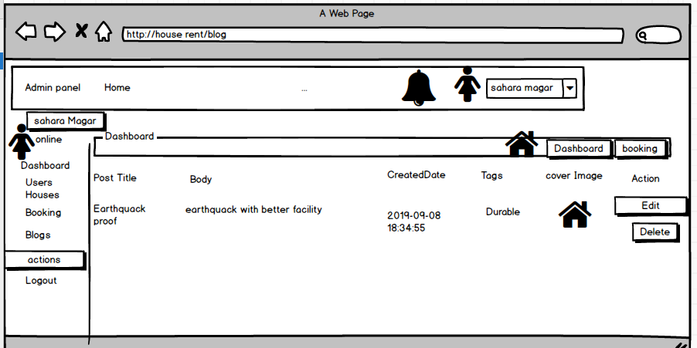

**Figure 29 list of blog used**

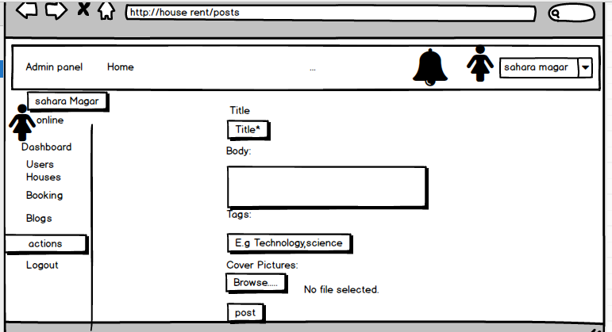

**Figure 30 form for posting blog**

# Chapter 4. Implementation

I have used Laravel programing language of do my whole project.

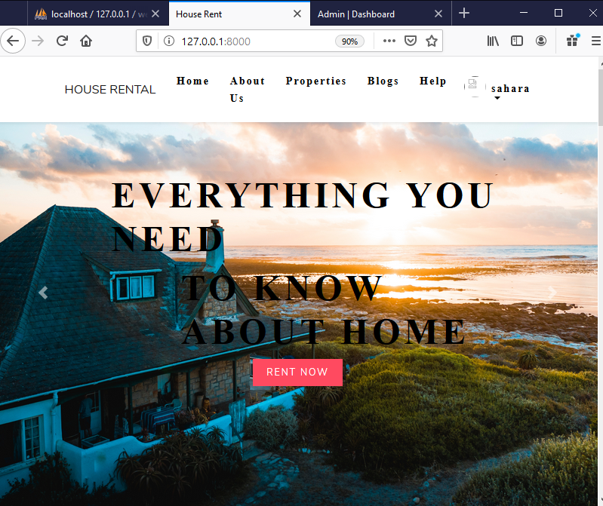

**Figure 31 Home page**

# Chapter 5. Testing

Testing is the stages after coding. For the effective presentation or performance of system testing is done. It is also done to ensure that any types of system ought not to result into any types of failures because it may cost high to compensate the error no time to recover and may be the final stage of the system where no any changes can be made. It helps to save the cost, future error are identified earlier, trustworthy product can be provided to the users, free vulnerability product can be deliver, assurance of the product quality can be made. So, testing is essential part of the software development which leads to the success of business. There are different types of methods used in testing.

I have used Unit testing and Black Box testing in order to test my system. Description of the Test that I have used during the system development are describe bellow.

## 5.1 Black Box Testing

It is also known as behavioural testing in which the functional and non-functional parts of the system are tested. Internal coding or structure of the system are not tested and consider only the input and output given by the system. This testing is based on software specification and requirements. (Anon., 2019)

I have chosen the Black box testing to test my system because of the following points;

1. Easy to done because we don’t have to shows the internal working process.
2. Validation of the functional requirements are more focused.
3. Non-technical users can easily understand the testing process.

Some of the black Box Testing are shown with diagram bellow.

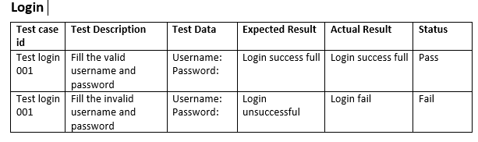

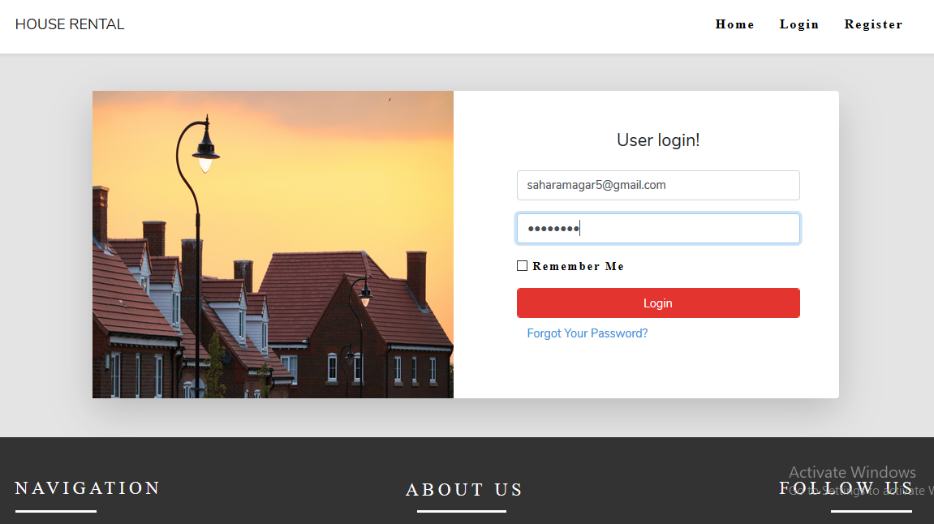

**Figure 32 Login Form for testing**

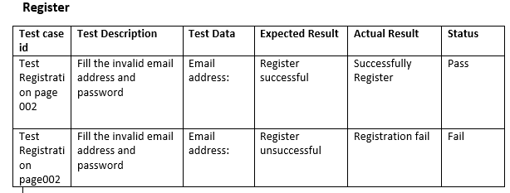

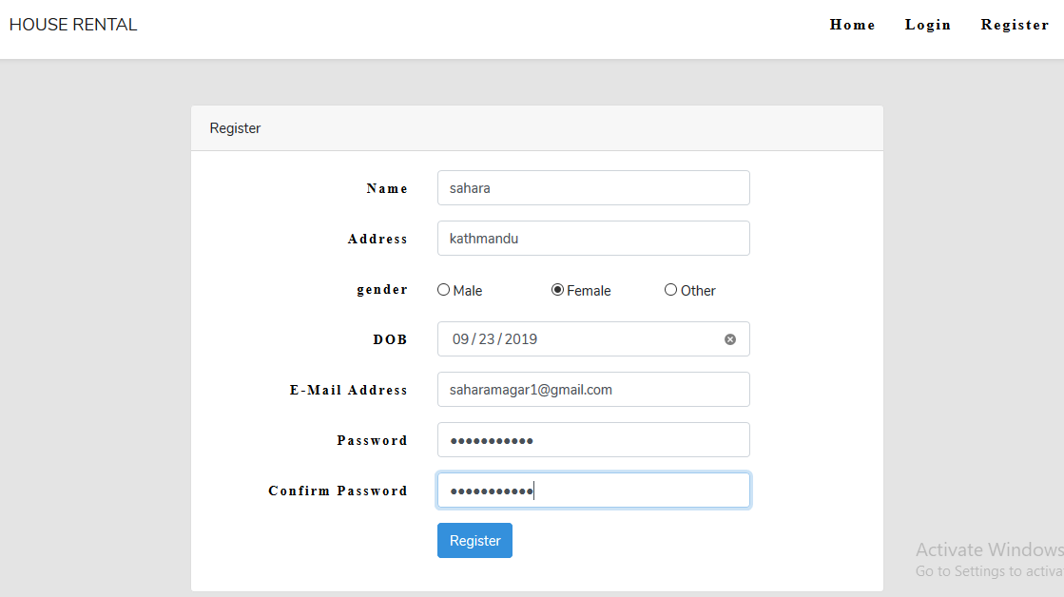

**Figure 33 Registration Form for Testing**

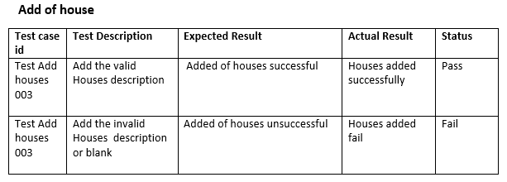

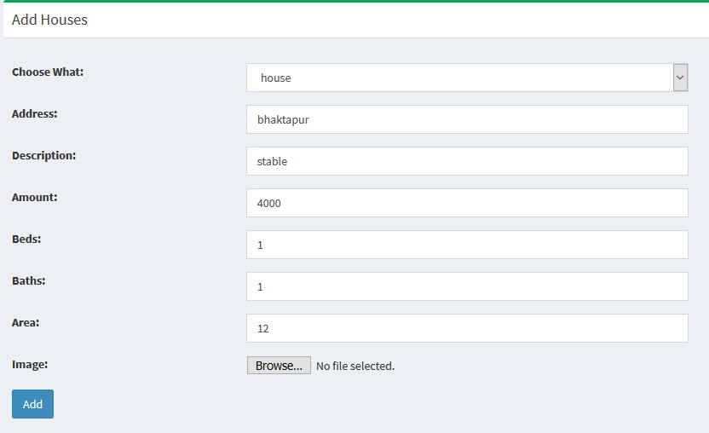

**Figure 34 Add House Form used for testing**

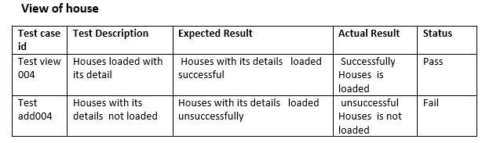

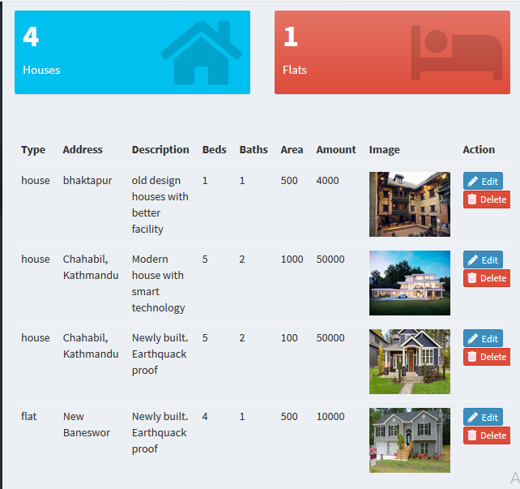

**Figure 35 View house form used for testing**

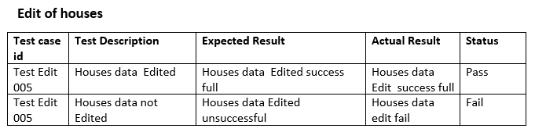

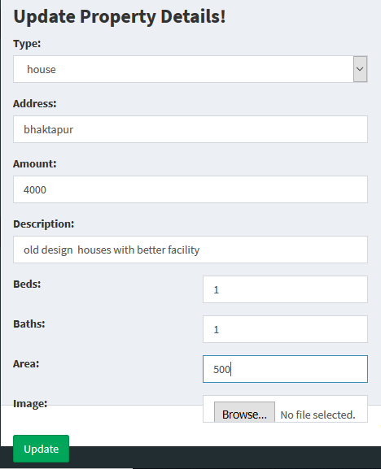

**36 Edit house form used in testing**

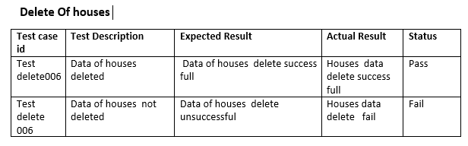

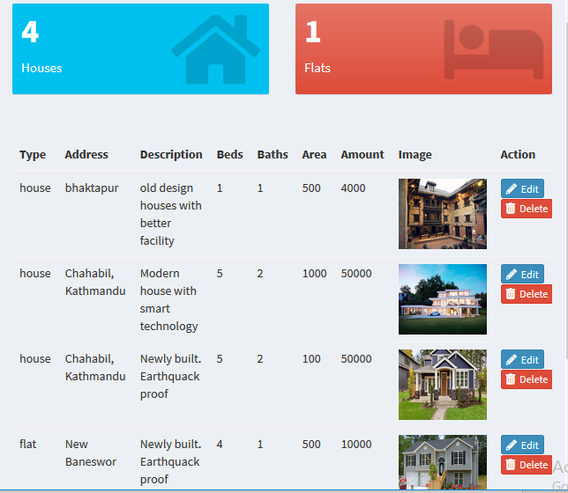

**Figure 37 Form before deleting the house**

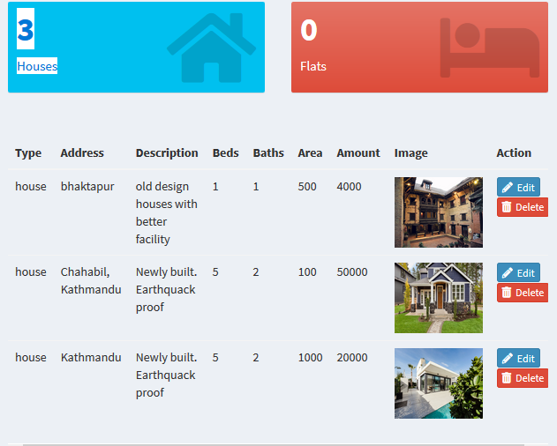

**Figure 38 Form After Delete of one House**

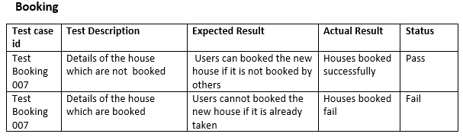

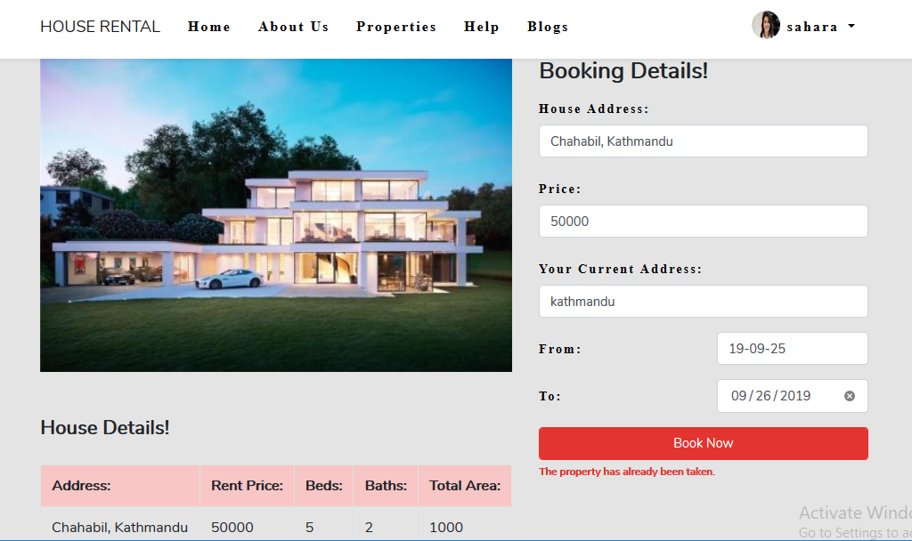

**Figure 39 Booking Form used in testing**

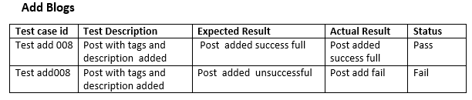

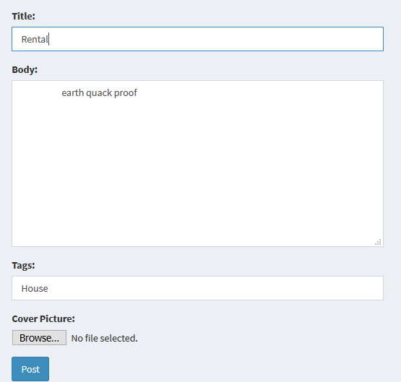

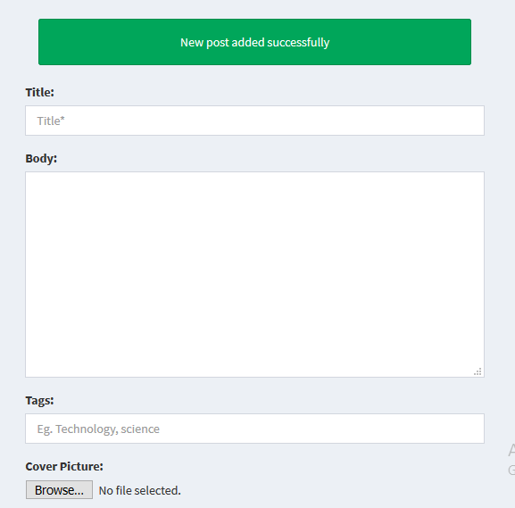

**Figure 40 Add Blog form used during testing**

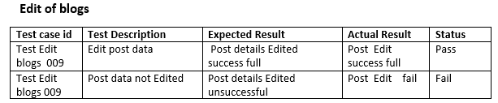

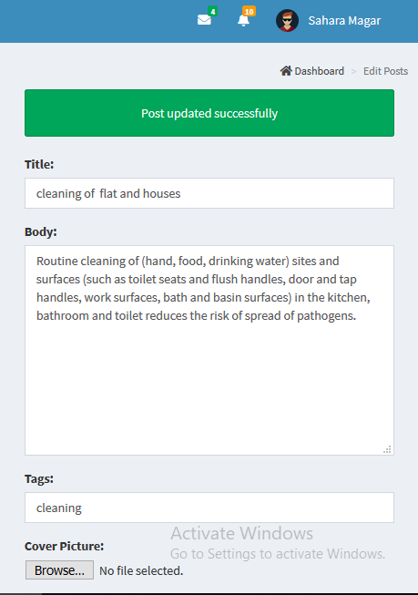

**Figure 41 Edit Bog form used during testing**

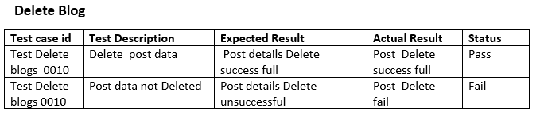

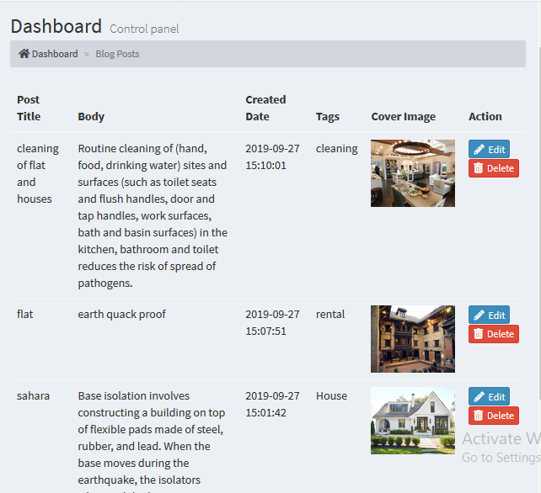

**Figure 42 Delete Blog Form**

## 5.2Unit Testing

Unit Testing is the method of testing the system in which the individual component of the source code are tested whether if they are fit to use in the system or not. Results of this types of testing should be single and out- put must be single. This types of testing helps in detecting the error in early stage before starting the integration testing. Debugging process can be simplified with the help of this testing.

# 6: Other project Issue

## 6.1 Limitation

Some of the limitation of the systems are given bellow;

1. To use the house Rental Management system users must have to login to their profile.
2. One users can only booked only one property.
3. Unless Admin confirm the property users are not allowed to book the property.
4. Users are not allowed to booked the property which are been already booked by others.
5. Mail sent by the users can only be seen by admin.

## 6.2 Future work

Some of the future work for the current project are listed below;

1. Search Rent based on Rent/Area set priority.
2. Transportation Tracking.
3. Online payment
4. Landlords Registration module.
5. Live chat between the registered users
6. Comment sections.
7. Blocking of users

## 6.3 Risk management

Risk management is the process of identifying and controlling or minimizing the threat in the company or organization. It should be done in the initial phase i.e. in planning phase in order to avoid the future consequences or risk.

Following are the method to control risk in Project Management.

Avoidance:

Reduction:

Sharing:

Retention:

**Impact = Likelihood * Consequence**

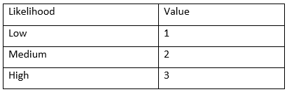

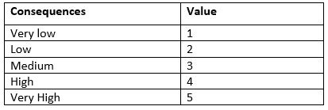

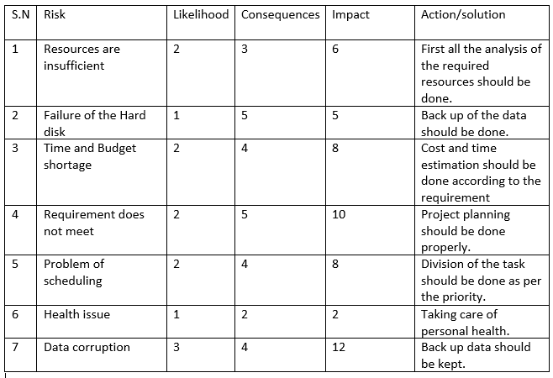

## 6.4 Configuration management

CM is the practice of handling changes systematically so that a system maintains it integrity over time. It also refers to the system which track software, hardware and related information of the system. It programs and plans provide technical and administrative direction to the development and implementation of the procedures, functions, services, tools, processes, and resources to develop and support a complex system.

The following point can shows why the configuration management should be used.

* With the use of CM we can have the structured and effective methodology for documentation, validating, releasing and changing the requirement in the business.
* Helps in team coordination.
* Any changes and updates are transparent within the team.

Cost reduction as by having all the element configuration information and detail already can reduce the UN necessary duplication.

**Github id:** <https://github.com/sahara1magar/CP>

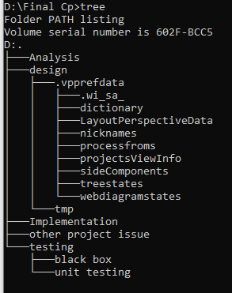

**Figure 43Tree structure for HRMS**

## 6.5 Other project issues

**Some of the other project issues are given bellow;**

1. **Technical issue:** Not easily accessible to all users to use the system.

Some users may feel difficult to use the system.

May not be applicable or run in all software.

1. **Social issue:** Some Age restriction are also provided to use the system.

Discrimination by social status in using the system.

1. **Legal issue:** Many legal Restriction rule are not implemented in building the system. copy right issues may occur

## 6.6 User manual



**Figure 44 home page of HRMS**

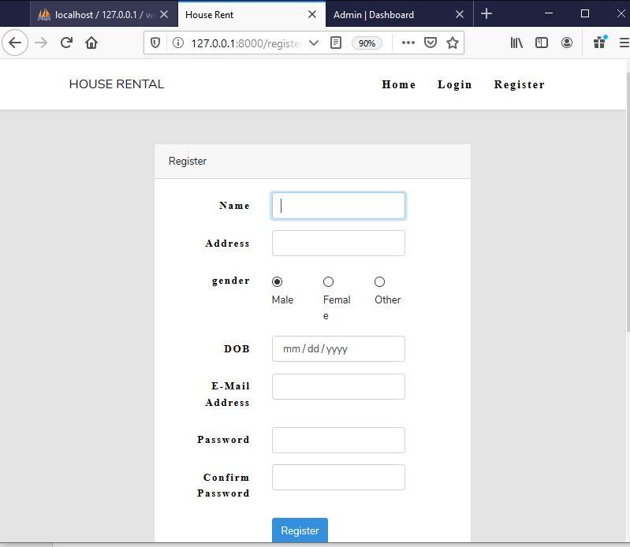

**Figure 45 Registration page for users**

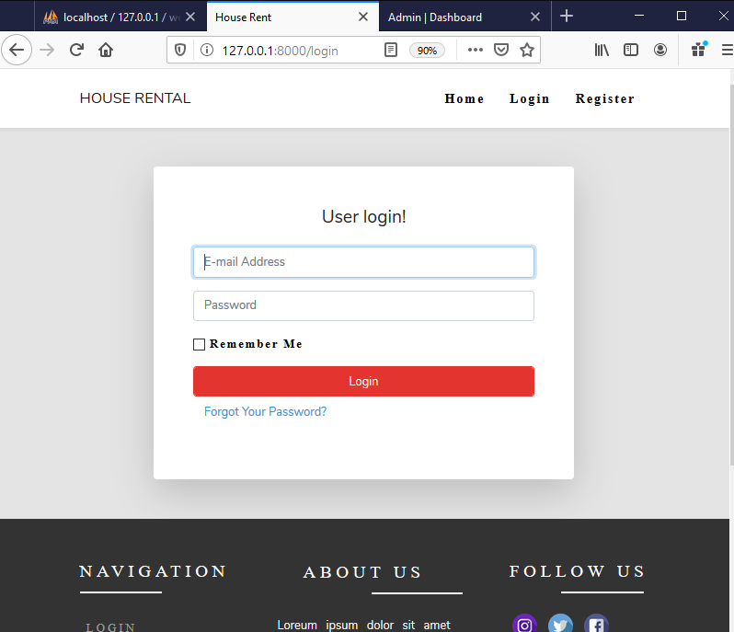

**Figure 46 login page for user**

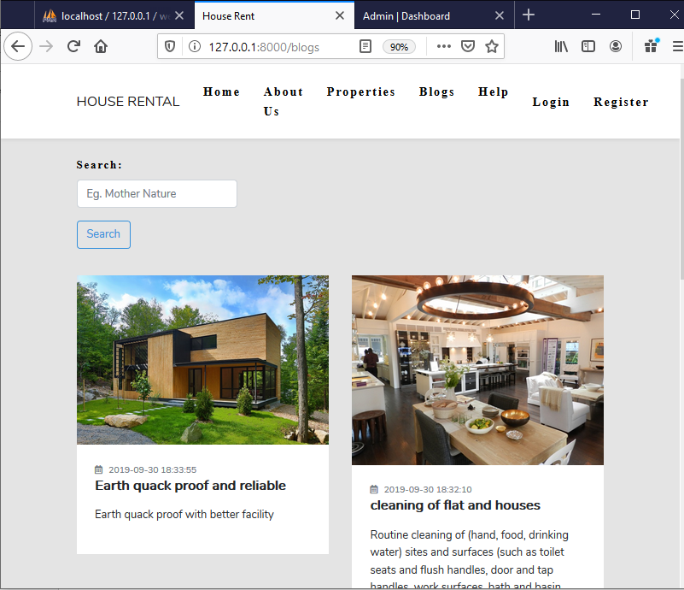

**Figure 47 blog page**

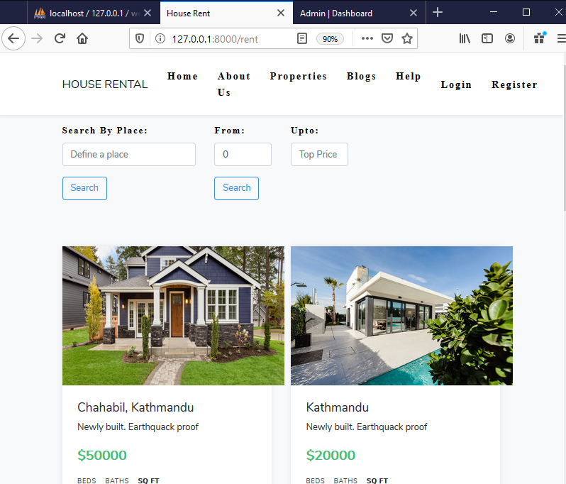

**Figure 48 property page**

# 7. Conclusion

House rental management system is the user friendly web application through which the users can booked, search and view property. They have to get login to the system to book the property. With the different types of the features the overview of the project is shown. Waterfall methodology and WBS diagram is also used for the project decomposition. Breakdown of the work also done with the scheduling of the time Gantt chart has been used. Prioritization of the work is done show that the functional requirement is first full filled. Different types of the diagram was done which shows the system structures. Sequence diagram, activity diagram, Er diagram and class diagram was drawn which represents the structure of the system. Helps link is also available through which users can get help in using the system. Any doubt in using the system can be clear by using the help button. Any users can sent the mail to the admin. The users will be notified if they provide the valid information then they will get the mail if their booking are conformed or not. So, this system will helps the users who are willing in searching the reliable house which can saves the cost and time of the users.

# 8. References

Anon., 2019. *softwarequality.* [Online]   
Available at: https://www.softwarequality.techtarget.com  
[Accessed 30 october 2019].

Anon., 2019. *softwaretestingclass.com.* [Online]   
Available at: https://www.softwaretestingclass.com/what-is-black-box-testing/  
[Accessed 30 october 2019].

Anon., 2019. *study.com.* [Online]   
Available at: https://study.com/academy/lesson/what-is-a-use-case-definition-examples.html  
[Accessed 2019 october 2019].

Donald S. Le Vie, J., 2019. *ratandon.mysite.syr.edu.* [Online]   
Available at: https://ratandon.mysite.syr.edu/cis453/notes/DFD_over_Flowcharts.pdf  
[Accessed 30 october 2019].

errrwr, 1999. *study.com.* [Online]   
Available at: http/study.com  
[Accessed 2019].

PHAM, V., 2019. *elabor8.com..* [Online]   
Available at: https://elabor8.com.au/rich-pictures-and-catwoe-simple-yet-powerful-scope-modelling-techniques/  
[Accessed 30 octtober 2019].

# 9. Appendix

Coding screen shorts are given bellow;

